Canva link-https://www.canva.com/design/DAFZZTz68ts/_CZcvJgN2R7AYUPVPeM3zQ/edit?utm_content=DAFZZTz68ts&utm_campaign=designshare&utm_medium=link2&utm_source=sharebutton

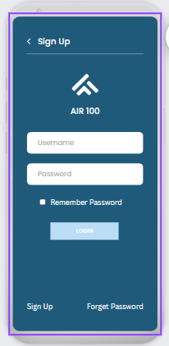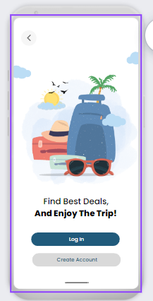App screenshots-

